

|  |  |
| --- | --- |
| **ANGELWINGS COMPREHENSIVE COLLEGE, MAROKO, PW, KUBWA, ABUJA** | |
| **THIRD TERM EXAMINATION 2024/2025 ACADEMIC SESSION** | |
| **SUBJECT: EAD** | **CLASS: NURSERY TWO** |

(1) Identify and color circle

(2) colour the dog brown

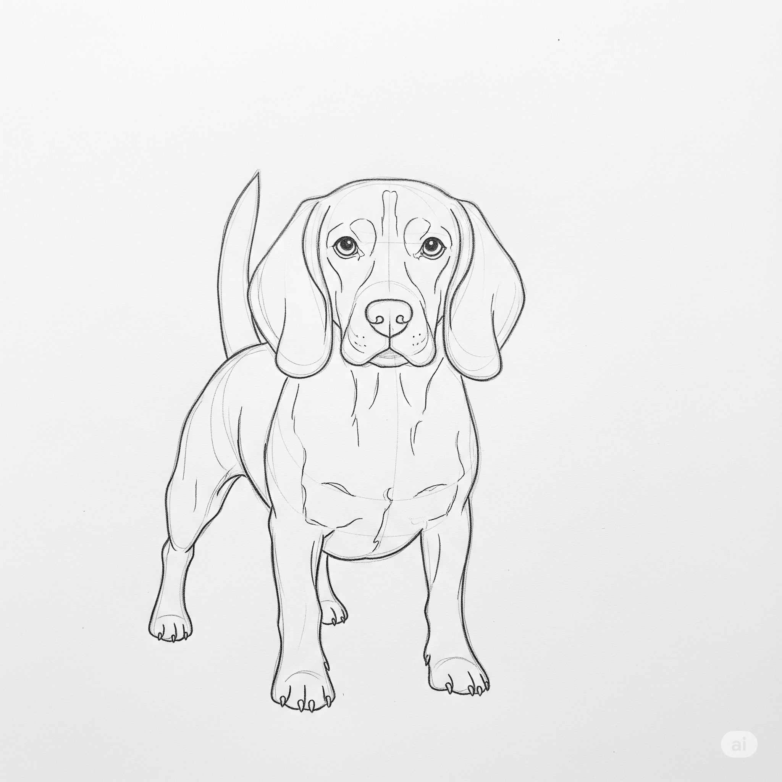

(3). Draw colour an orange

(4) Identify and colour a triangle

(5) Trace your Left and right fingers and colour